- An instruction in MIPS assembly language
Instruction choices are:
ADD, ADDI, SUB, AND, ANDI, NOR, ORI, SLT, SLTI, LW, SW, BEQ, BNE, J
- The instruction translated to MIPS machine language in binary, and then converted to hexadecimal.
- A description of what the instruction will do, given specific values (you specify them) in the operand registers.
Everyone should choose a DIFFERENT instruction/operand combination. Therefore, you must read all the previous student postings before you post yours, to insure your choice is unique.
Include the instruction you are covering in the SUBJECT line. For example:
Subject: MIPS Instruction Example ADD
Post your example in the Discussion Question: MIPS Instruction Examples topic of Week 2 discussion forum .

A simple subtraction example:
Java
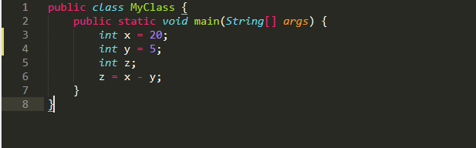
Add immediately 20 in register $s1 for variable x in code;
Init x with constant 20;
Init y with constant 5;
Declare z with null value;
Subtract y from x and store result in z;

MIPS
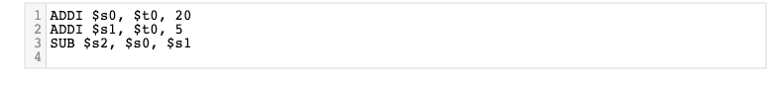
Add immediately 20 in register $s0 for variable x in code;
Add immediately 5 in register $s1 for variable y in code;
Subtract $s0 from $s1 and store result in $s2 which is in code variable z;

ADDI | $t0 | $s0 | immediate
001000  6 | 01000  5 | 10000  5 | 0000000000010100  16

Binary: 00100001000100000000000000010100

Hex: 0x21100014

ADDI | $t0 | $s1 | immediate
001000  6 | 01000  5 | 10001  5 | 0000000000000101  16

Binary: 00100001000100010000000000000101

Hex: 0x21110005

SPECIAL | $s0 | $s1 | $s2 | 0 | sub
000000  6 | 10000  5 | 10001  5 | 10010  5 | 00000  5 | 100010  6

Binary: 00000010000100011001000000100010

Hex: 0x02119022

